Tempus Fugit WordClock Templates

The following 2 pages contain templates for English, French, Dutch and Latin versions of the WordClock.

* Positive and Negative versions of each are included, by placing the negative versions ‘white’ side up the blank letters are hidden.
* For best result I recommend laminating the templates with a thermal laminator – this is how the templates included with the clock kits were made.
* To fix the templates to the display I have found ‘Pritt Stick’ type glues to be really effective.   
  Interestingly I did not found the display mount spay glues not to work
* A particular advantage of using a paper glue like this is that you can get the template off  
  and start again without damaging the display
* The TF s/w includes an alignment mode to help position the template correctly. To put  
  the TF into this mode hold S1 down during the start up ‘bar’ sequence – see the instructions  
  for more on this
* For best results print this out on thin copier paper (75gms or less),
* An alternative is to print on to OHP paper. I have found that Inkjet OHP transparencies give better blacks that laser OHP transparencies. The Transparencies let a lot more light through so give better results if you are using the TF in bright conditions.
* With care I have found you can laminate transparencies in much the same way you do paper, but it is worth noting that doing this could invalidate any warrantee on your laminator if you have a problem
* I have found printing from MS Word and Publisher the template sizes were maintained well through the printing process.
* Printing from Adobe PDF files did not give good results, so I have not included PDF versions here

|  |  |  |  |  |  |  |  |
| --- | --- | --- | --- | --- | --- | --- | --- |
| **H** | **A** | **T** | **W** | **E** | **N** | **T** | **Y** |
| **F** | **I** | **F** | **V** | **T** | **E** | **E** | **N** |
| **L** | **F** | **\*** | **P** | **A** | **S** | **T** | **O** |
| **N** | **I** | **N** | **E** | **I** | **G** | **H** | **T** |
| **O** | **N** | **E** | **T** | **H** | **R** | **E** | **E** |
| **T** | **W** | **E** | **L** | **E** | **V** | **E** | **N** |
| **F** | **O** | **U** | **R** | **F** | **I** | **V** | **E** |
| **S** | **I** | **X** | **S** | **E** | **V** | **E** | **N** |

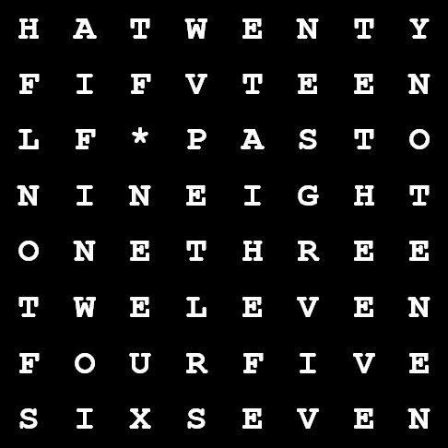

English



|  |  |  |  |  |  |  |  |
| --- | --- | --- | --- | --- | --- | --- | --- |
| **D** | **O** | **E** | **U** | **S** | **I** | **X** | **Z** |
| **T** | **R** | **O** | **N** | **I** | **S** | **Z** | **E** |
| **Q** | **U** | **A** | **T** | **R** | **E** | **P** | **T** |
| **C** | **H** | **N** | **E** | **U** | **I** | **T** | **F** |
| **I** | **N** | **Q** | **H** | **E** | **U** | **R** | **E** |
| **M** | **O** | **I** | **N** | **S** | **D** | **I** | **S** |
| **E** | **T** | **\*** | **Q** | **U** | **A** | **R** | **T** |
| **D** | **E** | **M** | **I** | **E** | **N** | **U** | **I** |

French

French



|  |  |  |  |  |  |  |  |
| --- | --- | --- | --- | --- | --- | --- | --- |
| **K** | **W** | **A** | **R** | **T** | **I** | **E** | **N** |
| **V** | **I** | **J** | **F** | **O** | **V** | **E** | **R** |
| **V** | **O** | **O** | **R** | **H** | **A** | **L** | **F** |
| **Z** | **E** | **S** | **Z** | **E** | **V** | **E** | **N** |
| **N** | **E** | **G** | **T** | **W** | **E** | **E** | **N** |
| **T** | **V** | **I** | **J** | **F** | **E** | **R** | **N** |
| **A** | **C** | **H** | **T** | **D** | **R** | **I** | **E** |
| **E** | **L** | **T** | **W** | **A** | **A** | **L** | **F** |

Dutch

Dutch

|  |  |  |  |  |  |  |  |
| --- | --- | --- | --- | --- | --- | --- | --- |
| **E** | **S** | **T** | **\*** | **H** | **O** | **R** | **A** |
| **P** | **R** | **I** | **M** | **A** | **T** | **E** | **R** |
| **S** | **E** | **C** | **U** | **N** | **D** | **A** | **T** |
| **Q** | **U** | **I** | **N** | **A** | **T** | **R** | **A** |
| **D** | **U** | **N** | **O** | **D** | **E** | **C** | **I** |
| **V** | **I** | **G** | **I** | **L** | **I** | **A** | **M** |
| **O** | **C** | **T** | **A** | **N** | **O** | **V** | **A** |
| **S** | **E** | **X** | **P** | **T** | **I** | **M** | **A** |

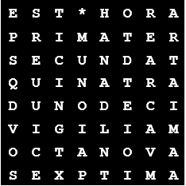

Latin